**Galaxy Buds2**

SM-R177NZKAMEA

[**Product Ratings :4.2(Number of Ratings :17)**](javascript:void(0))

* Well-balanced Sound
* Battery Life
* ANC

**Looking for alternatives?**

[[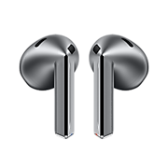](https://www.samsung.com/pk/audio-sound/galaxy-buds/galaxy-buds3-silver-bluetooth-sm-r530nzaamea/)](https://www.samsung.com/pk/audio-sound/galaxy-buds/galaxy-buds3-silver-bluetooth-sm-r530nzaamea/)

[**Galaxy Buds3**](https://www.samsung.com/pk/audio-sound/galaxy-buds/galaxy-buds3-silver-bluetooth-sm-r530nzaamea/)

**Rs. 51,999.00**

[Product Ratings :2.1](https://www.samsung.com/pk/audio-sound/galaxy-buds/galaxy-buds3-silver-bluetooth-sm-r530nzaamea/#reviews)

[**Learn more**](https://www.samsung.com/pk/audio-sound/galaxy-buds/galaxy-buds3-silver-bluetooth-sm-r530nzaamea/)

[[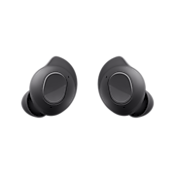](https://www.samsung.com/pk/audio-sound/galaxy-buds/galaxy-buds-fe-graphite-sm-r400nzaamea/)](https://www.samsung.com/pk/audio-sound/galaxy-buds/galaxy-buds-fe-graphite-sm-r400nzaamea/)

[**Galaxy Buds FE**](https://www.samsung.com/pk/audio-sound/galaxy-buds/galaxy-buds-fe-graphite-sm-r400nzaamea/)

**Rs. 33,399.00**

[Product Ratings :4.7](https://www.samsung.com/pk/audio-sound/galaxy-buds/galaxy-buds-fe-graphite-sm-r400nzaamea/#reviews)

[**Learn more**](https://www.samsung.com/pk/audio-sound/galaxy-buds/galaxy-buds-fe-graphite-sm-r400nzaamea/)

**Choose your color**

**Color :**Graphite

**Galaxy Buds2**

Graphite

[**Where to buy**](javascript:;)

**key features**

Well-Balanced Sound

Active Noise Canceling

Comfort Fit

**Galaxy Buds2**

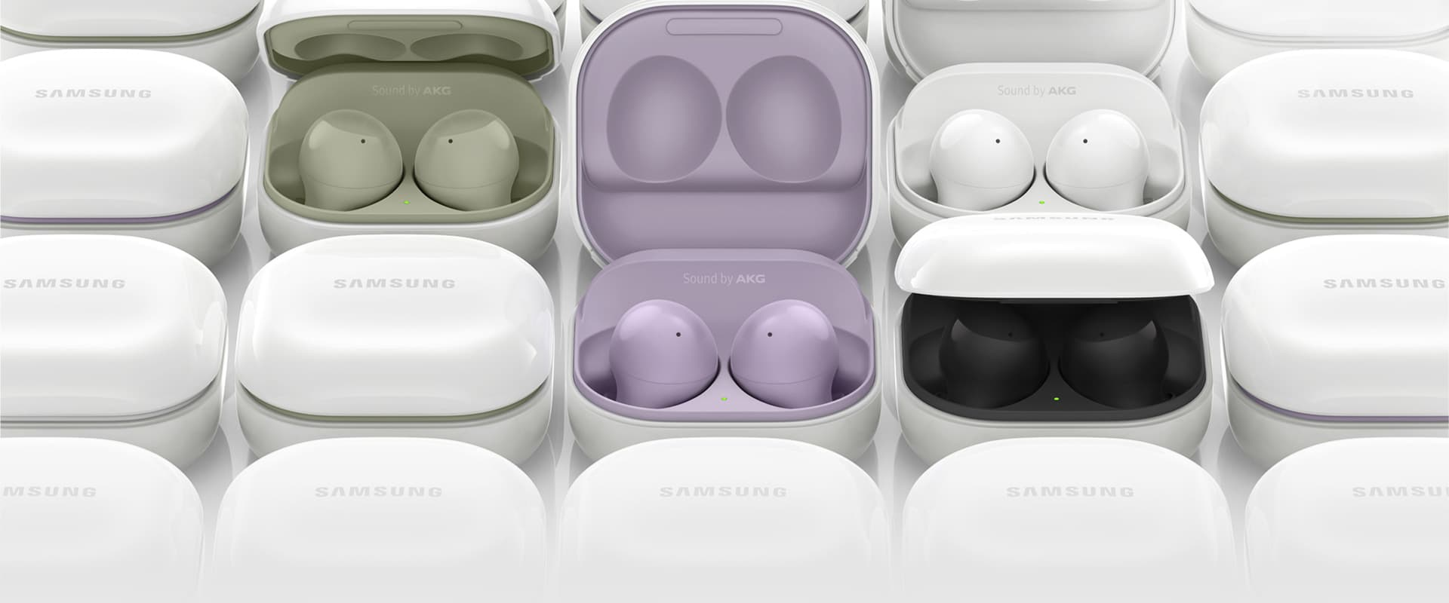

**Immerse yourself  
into your own world**

Get lost in what you love. Galaxy Buds2 opens a new world of audio experience with well-balanced sound, unmatched comfort fit, ANC, and seamless connectivity to your phone and watch. Easier controls and better feedback keep you immersed when working out, gaming, or jamming to your beats. [1](https://www.samsung.com/pk/audio-sound/galaxy-buds/galaxy-buds2-graphite-sm-r177nzkamea/#desc-section)

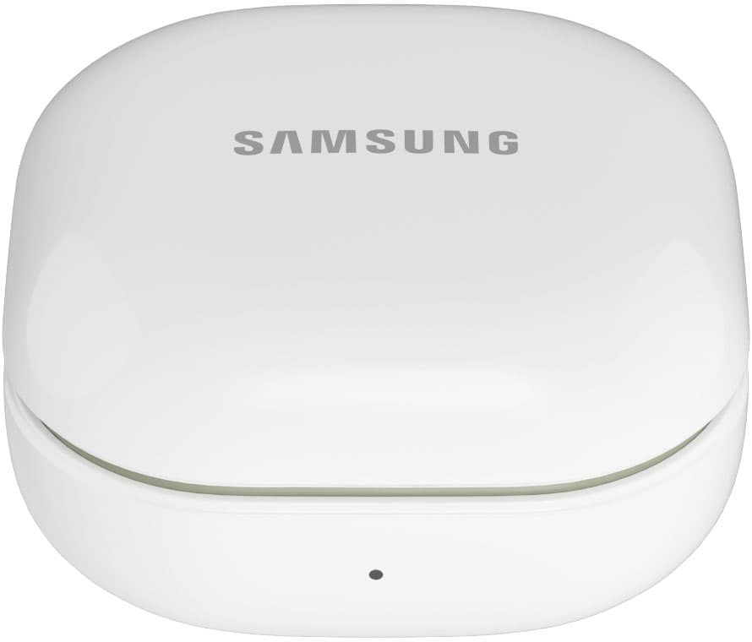

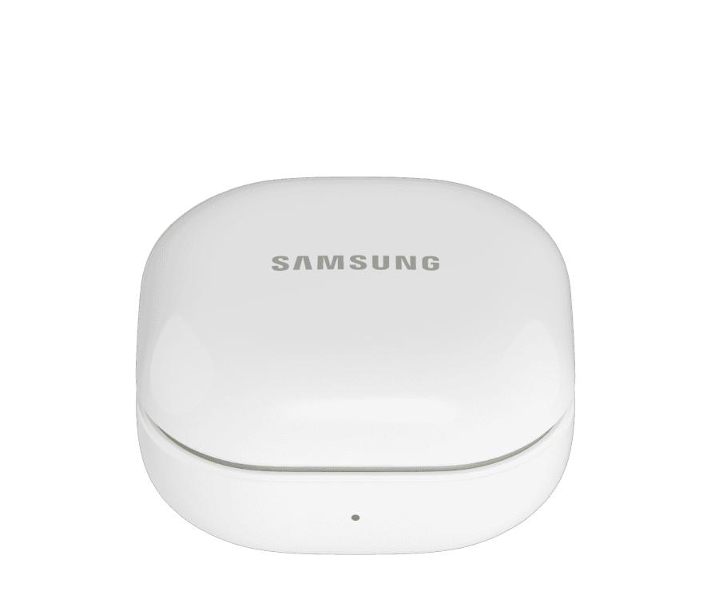

The front of the Galaxy Buds2 case is shown open, with two Galaxy Buds2 earbuds placed inside the case. The exterior of the Galaxy Buds2 case is in a white color, and the interior of the case, including the two Galaxy Buds2 earbuds, are in an olive color.

**Galaxy AI is here**

Elevate your Galaxy AI experience with Galaxy Buds2. Now you have a translator right in your ear. Turn on the translation features on your Samsung Galaxy smartphone with Galaxy Buds2 on. Make friends with no language barrier when talking face-to-face or over the phone.

[[](javascript:void(0);)](javascript:void(0);)

**[Face-to-face](javascript:void(0);)**

[[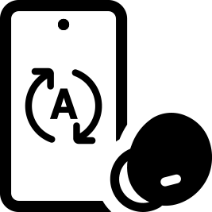](javascript:void(0);)](javascript:void(0);)

**[Over the phone](javascript:void(0);)**

Keep your Galaxy Buds2 on, even when you need to use Interpreter on Samsung Galaxy smartphone. Hear the translation through the earbuds, while the other person listens via the paired smartphone's speaker. Enjoy smooth conversations without handing over your phone each time you speak.

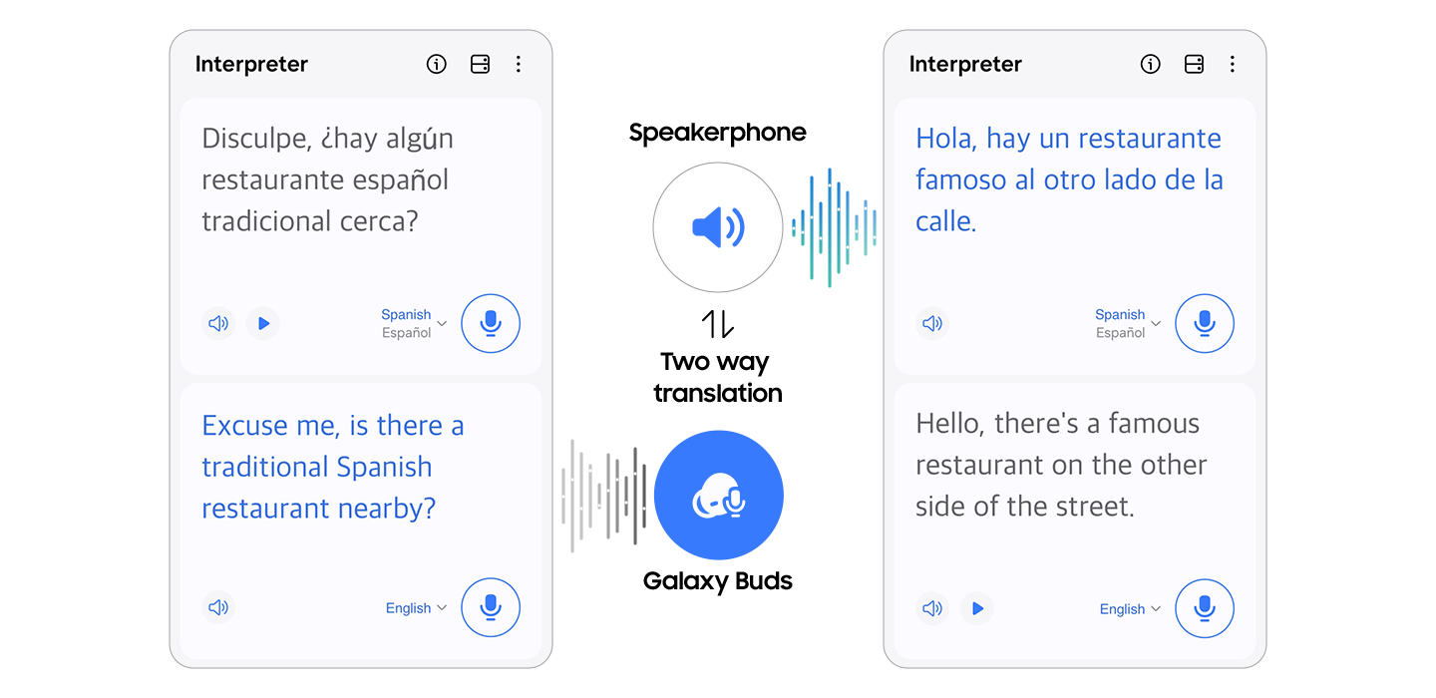

*Interpreter feature requires Samsung Account login. Certain languages may require language pack download. Service availability may vary by language. Accuracy of results is not guaranteed.  
*Live Translate feature requires a network connection and Samsung Account login. Live Translate feature is only available on the pre-installed Samsung Phone app. Certain languages may require language pack download. Service availability may vary by language, country, region or carrier. Accuracy of results is not guaranteed.  
*Galaxy AI features are supported on Galaxy S24 Ultra, S24 Plus and S24 as of Feb. 2024.  
*Samsung Galaxy devices may require the latest software update to properly support Galaxy AI features.  
*Images simulated for illustrative purposes. Actual UX/UI may be different.

**WELL-BALANCED SOUND**

**Your world the way  
it’s meant to be heard**



A woman is wearing olive color Galaxy Buds2 in her ear while riding a skateboard down an asphalt street. She is spreading her arms out and enjoying the ride. A man is in the background, also riding a skateboard by sitting on it.

Enjoy powerful, deep bass to clear treble through  
two-way dynamic speakers. The Galaxy Buds2 gives you well-balanced sound quality that enriches every moment of your audio journey. Hear like you’re there.

**CRYSTAL-CLEAR CALLS**

**Leave noise out  
of the conversation**

Three microphones and a built-in voice pickup unit help you make clearer calls, while a machine-learning based solution filters unwanted sound so you can better share your world with family and friends. The low protrusion design minimizes wind disruptions to make your outdoors calls come in clear. [2](https://www.samsung.com/pk/audio-sound/galaxy-buds/galaxy-buds2-graphite-sm-r177nzkamea/#desc-section)

An olive color Galaxy Buds2 earbud is split in half and its inner components are shown in order. The outermost shell is opened and inside is a chipset with 1 inner mic. There is also a component with 2 outer mics(Beamforming) and VPU(voice pickup unit).

**1 Inner  
Mic**

**2 Outer Mic  
(Beamforming)**

**VPU  
(Voice Pickup Unit)**

**ACTIVE NOISE CANCELING**

**Choose the sound  
you want to hear**

Two microphones detect ambient noise while Active Noise Canceling blocks unwanted sound. Background noise can be reduced up to 98% to keep you fully immersed in your music, games, audio books, and your favorite podcasts. [3](https://www.samsung.com/pk/audio-sound/galaxy-buds/galaxy-buds2-graphite-sm-r177nzkamea/#desc-section),[4](https://www.samsung.com/pk/audio-sound/galaxy-buds/galaxy-buds2-graphite-sm-r177nzkamea/#desc-section)

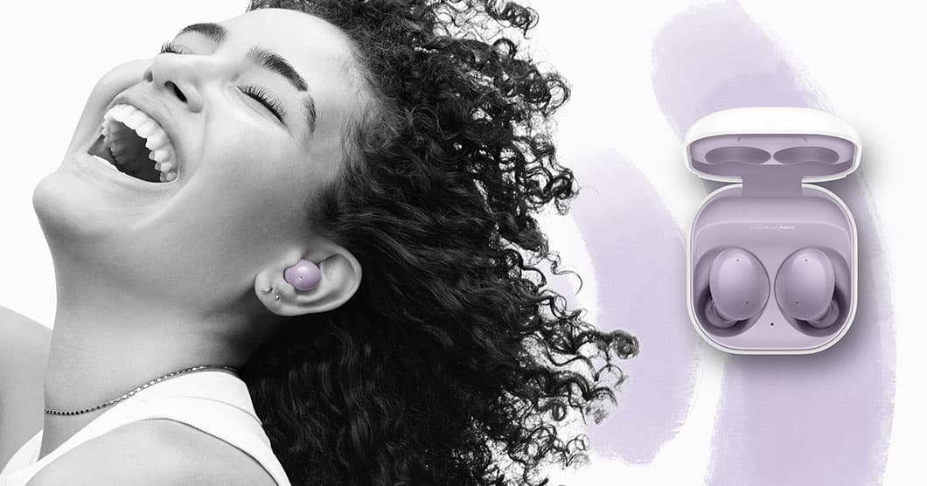

A woman is enjoying music while wearing a lavender color Galaxy Buds2. A Galaxy Buds2 case is displayed next to her, which is lavender color on the inside and white on the outside.



Active Noise Canceling (ANC) On Galaxy Buds2 cuts external background  
noise by up to 98%, backed by UL Verification

Tune into or out of the world around you with an easily adjustable three-level ambient sound option.

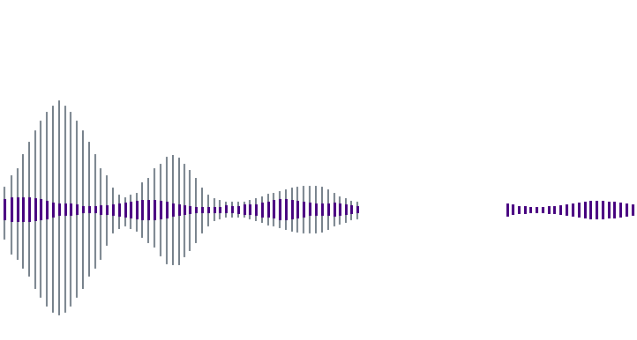

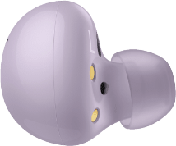

**Ambient Sound**

**ANC**

**High**

**Medium**

**Low**

A lavender Galaxy Buds2 earbud is shown over an illustration that depicts the three levels of ambient sounds that can be adjusted for ANC, from low, medium, to high.

**360 AUDIO**

**Get 360 Audio and be completely immersed**

360 Audio places sound all around you, while Dolby Head Tracking™ technology delivers an incredible three-dimensional listening experience. And with Dolby Atmos®, the audio becomes exceptionally detailed, letting you do more than just listen - you'll feel the story happening in front of you.

*Available only on Samsung Galaxy smartphones and tablets with Android One UI version 3.1 or later. 360 Audio and Dolby Head Tracking™ support may vary depending on app and content.



A set of onyx-colored Galaxy Buds2 slides to the center of the screen. The left side appears from the bottom left corner with the outside part facing forward and the right side appears from the top right with the inside part facing forward to reveal the R and various speaker and mic components. As they meet in the middle, they rotate as a pair 360 degrees to reveal all aspects of both sides.

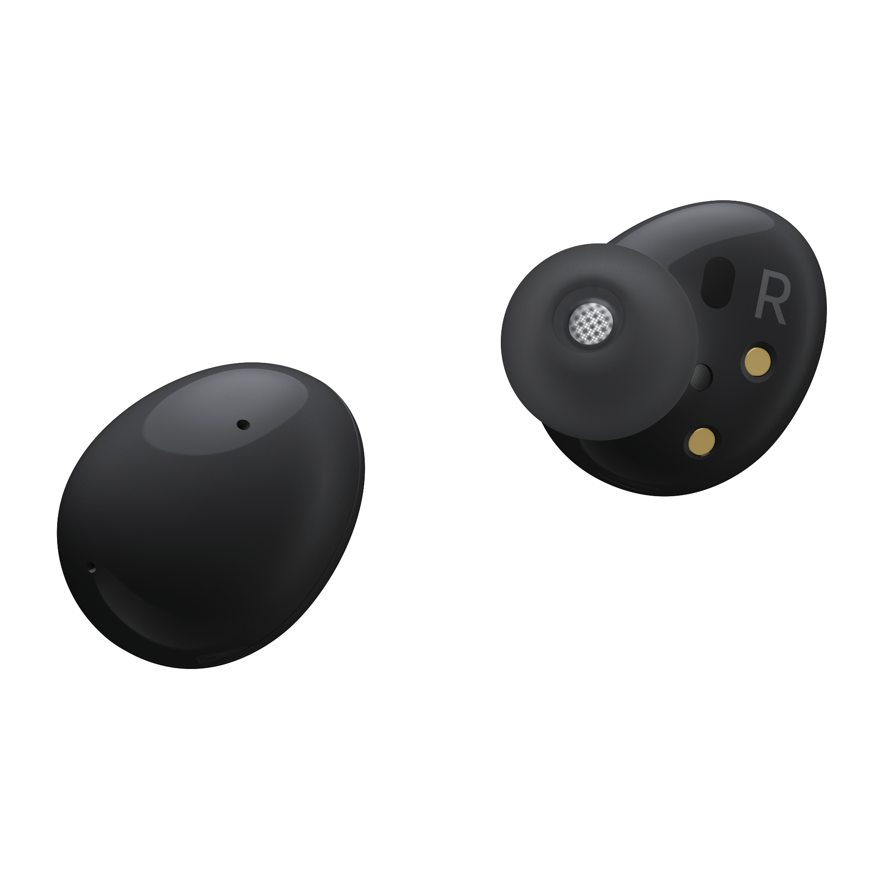

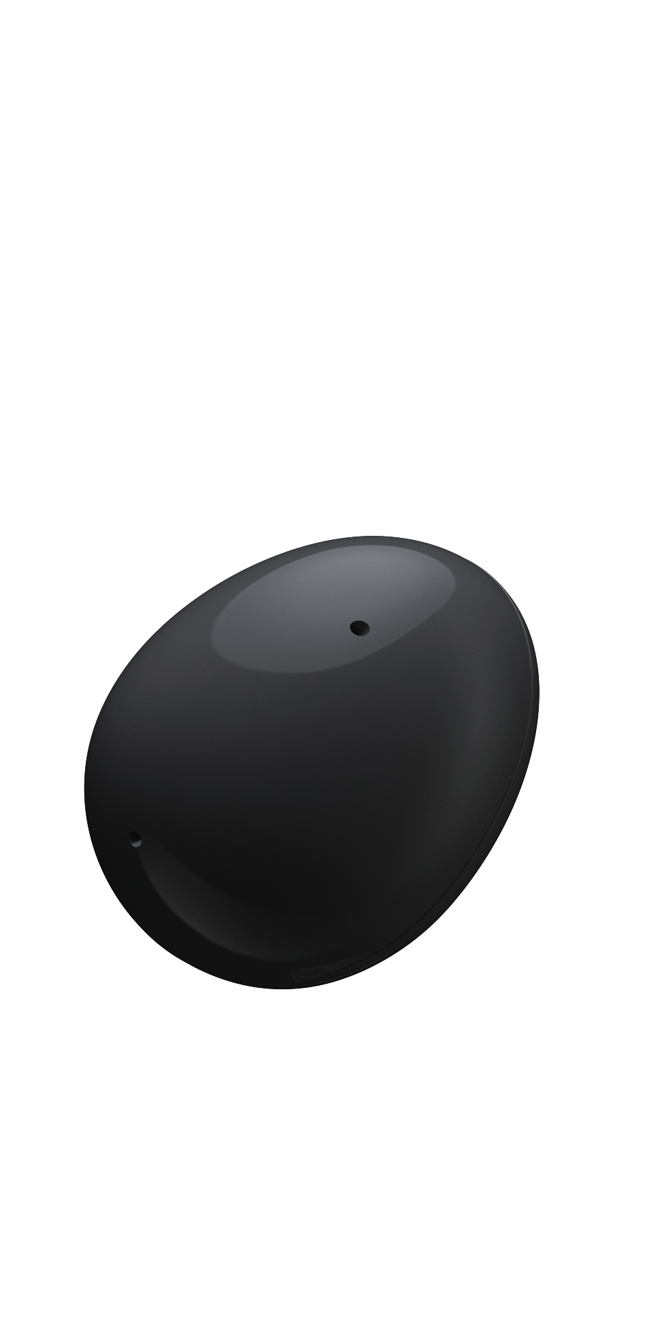

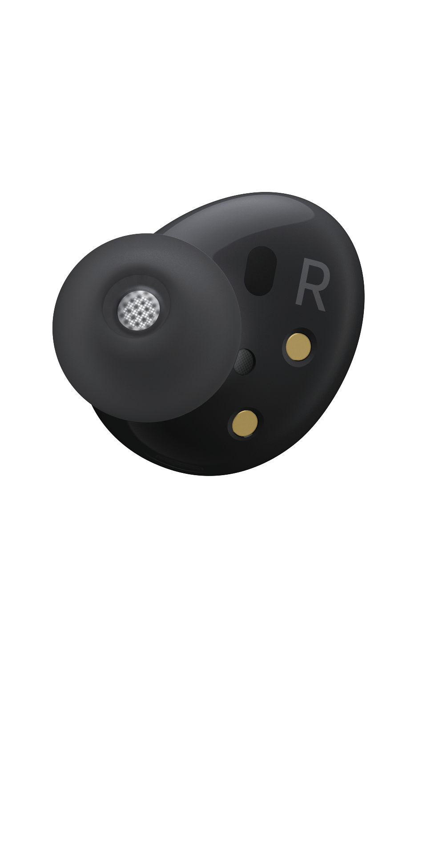

**SOUND CUSTOMIZATION**

**Sounds tailored to  
your taste**

Your every audio experience is tailored to your taste with Galaxy Buds2. With six different equalizer settings to choose from, you'll find your own pitch perfect, vibrant sound that keeps you immersed.

How to change equalizer Setting

**Step 3**

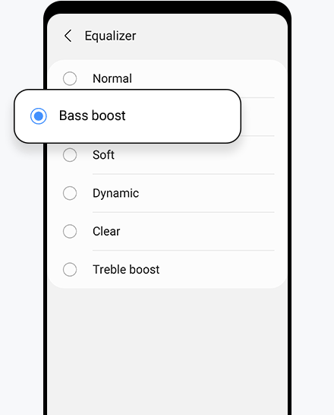

step 3) Different options for the equalizer setting is shown.

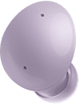

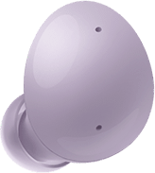

* [Step 1](https://www.samsung.com/pk/audio-sound/galaxy-buds/galaxy-buds2-graphite-sm-r177nzkamea/#none)
* [Step 2](https://www.samsung.com/pk/audio-sound/galaxy-buds/galaxy-buds2-graphite-sm-r177nzkamea/#none)
* [Step 3](https://www.samsung.com/pk/audio-sound/galaxy-buds/galaxy-buds2-graphite-sm-r177nzkamea/#none)

**DESIGN**

**Looks as  
good as  
it sounds**

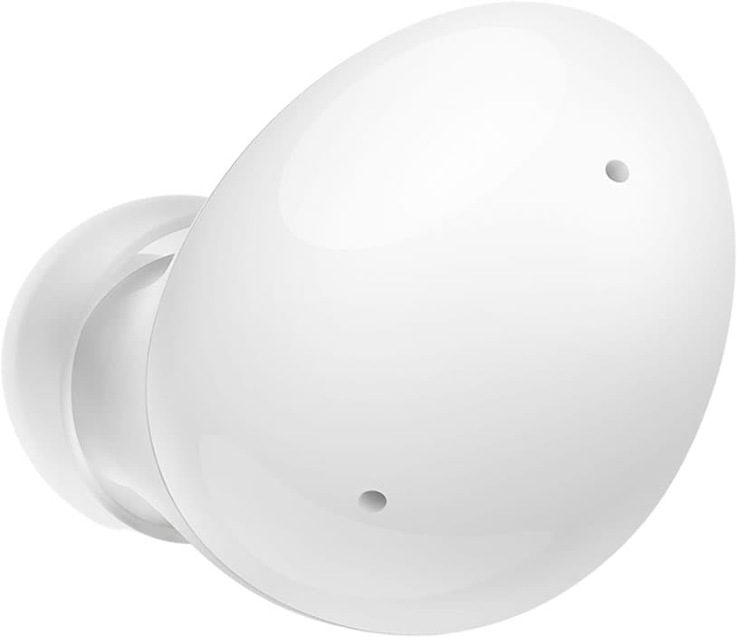

**COMFORT FIT**

**The lightest earbuds  
we've ever made**

Galaxy Buds2 is lightweight (5g each) and keeps music snug in your ears for even the most active lifestyles. With three sizes of soft, flexible silicon tips you can find a custom fit to get the best ANC experience possible. Find your fit with the **“Earbud fit test”** menu in the Galaxy Wearable app.

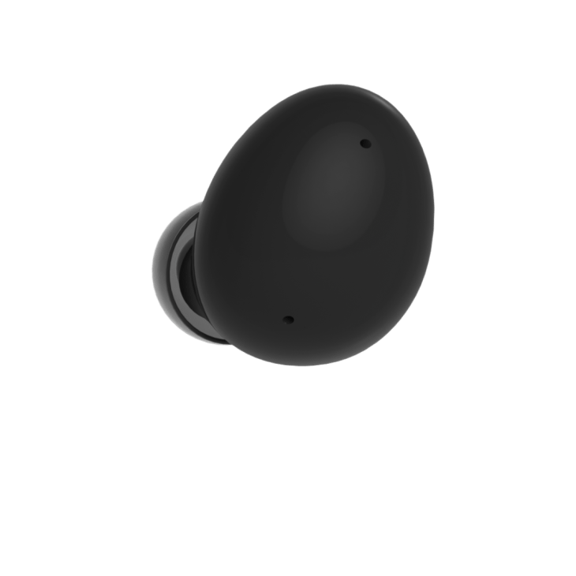

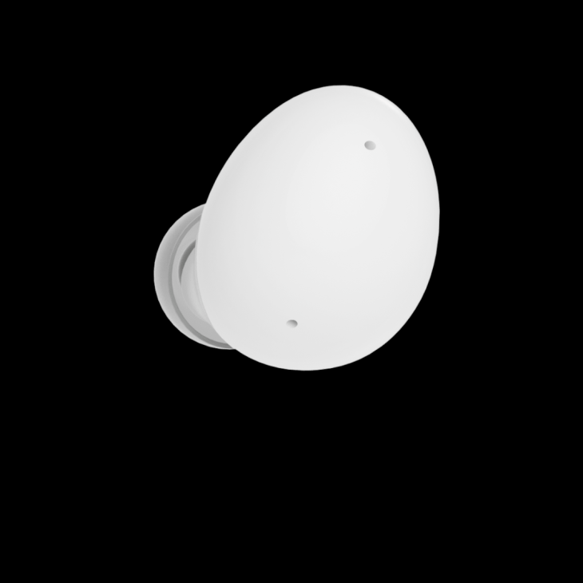

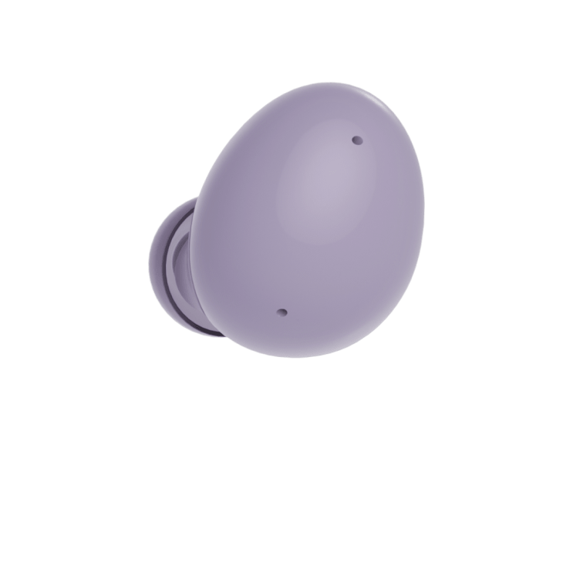

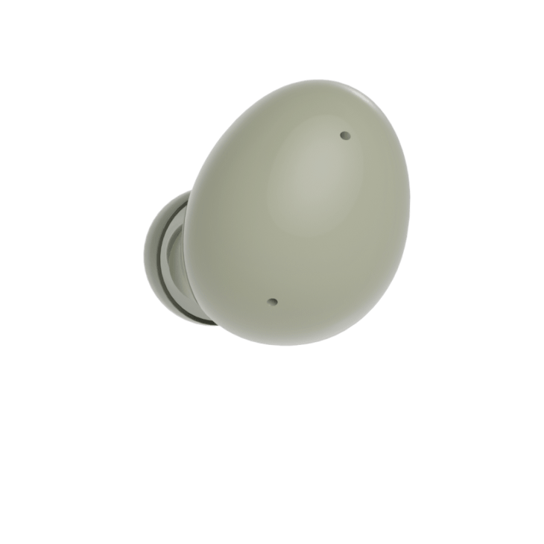









Eight single Galaxy Buds2 earbuds are placed in a circle. The earbuds are different in color in clockwise order starting from lavender, olive, black, and white.

Pick your ear-tip size for full comfort

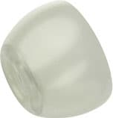

Small

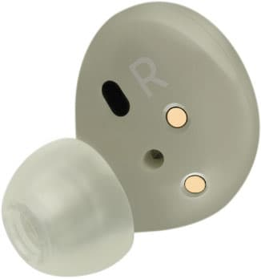

Medium

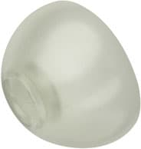

Large

The ear-tip of an olive color Galaxy Buds2 earbud is shown with different size tips from small, medium, to large.

**COLOR OPTIONS**

**Find your  
perfect tone**

Chic Onyx. Classical graphite. Flawless white. Soothing olive. Stylish lavender. Each earbud comes in a fashion-forward design and matching cases to fit your unique taste. With a widely compatible cradle design, the case keeps your earbuds safe, recharged, and easily portable. [5](https://www.samsung.com/pk/audio-sound/galaxy-buds/galaxy-buds2-graphite-sm-r177nzkamea/#desc-section)

* [**Onyx**](https://www.samsung.com/pk/audio-sound/galaxy-buds/galaxy-buds2-graphite-sm-r177nzkamea/#budsPanelOnyx)

* [**Olive**](https://www.samsung.com/pk/audio-sound/galaxy-buds/galaxy-buds2-graphite-sm-r177nzkamea/#budsPanelOlive)

* [**White**](https://www.samsung.com/pk/audio-sound/galaxy-buds/galaxy-buds2-graphite-sm-r177nzkamea/#budsPanelWhite)

* [**Lavender**](https://www.samsung.com/pk/audio-sound/galaxy-buds/galaxy-buds2-graphite-sm-r177nzkamea/#budsPanelLavender)

* [**Graphite**](https://www.samsung.com/pk/audio-sound/galaxy-buds/galaxy-buds2-graphite-sm-r177nzkamea/#budsPanelGraphite)

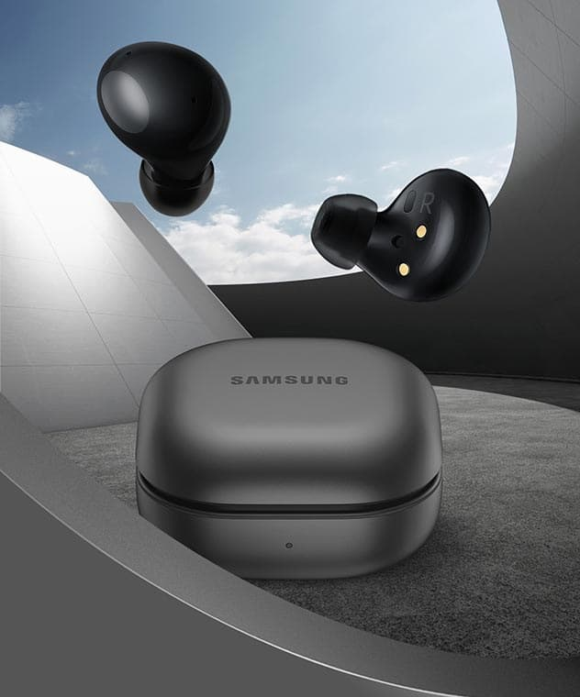

An onyx-colored Galaxy Buds2 case sits in a modern grey setting with a blue sky outside a window in the background. A pair of black Buds2 earbuds is floating above the case. There is an open Buds2 case with two Buds2 earbuds inside.

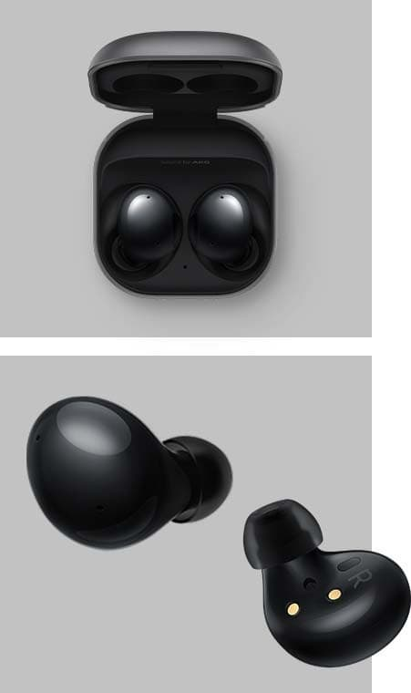

**BATTERY LIFE**

**Plenty of play time,  
wherever you go**

Whether you're watching your favorite shows, blazing through your playlist, or enjoying the outdoors, Galaxy Buds2 keeps you connected and comfortable all day long. The long lasting battery life gives you up to 5 hours of play-time and 15 more with a fully charged case. [6](https://www.samsung.com/pk/audio-sound/galaxy-buds/galaxy-buds2-graphite-sm-r177nzkamea/#desc-section),[7](https://www.samsung.com/pk/audio-sound/galaxy-buds/galaxy-buds2-graphite-sm-r177nzkamea/#desc-section)

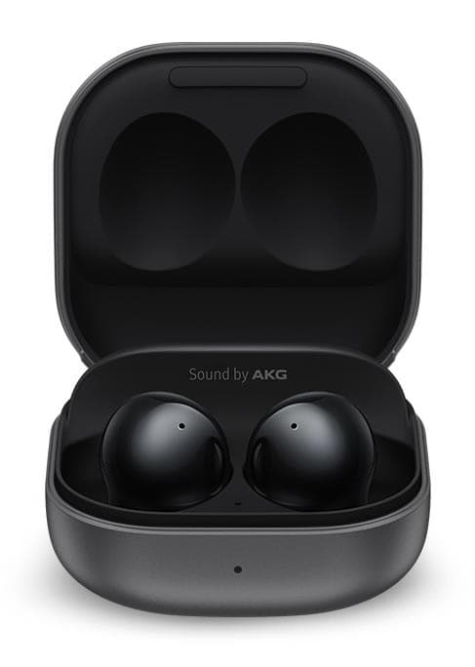

An onyx-colored Galaxy Buds2 case is open and facing forward. The interior of the case is black, and both earbuds are placed in the case.

5hours

Up to 5 hours of play time with ANC on

20total hours

Up to a total 20 hours of play time when  
charged using the case

**SMOOTH SYNCING**

**Switch without  
missing a beat**

With Auto Switch, moving between your Galaxy devices is easier than ever. Go from watching a movie on your tablet to playing music on the Galaxy Watch4, all hands free. Galaxy Watch4 also supports Quick Buds Control [8](https://www.samsung.com/pk/audio-sound/galaxy-buds/galaxy-buds2-graphite-sm-r177nzkamea/#desc-section), helping you turn ANC on or off, or check battery life right from your wrist. [9](https://www.samsung.com/pk/audio-sound/galaxy-buds/galaxy-buds2-graphite-sm-r177nzkamea/#desc-section),[10](https://www.samsung.com/pk/audio-sound/galaxy-buds/galaxy-buds2-graphite-sm-r177nzkamea/#desc-section),[11](https://www.samsung.com/pk/audio-sound/galaxy-buds/galaxy-buds2-graphite-sm-r177nzkamea/#desc-section)

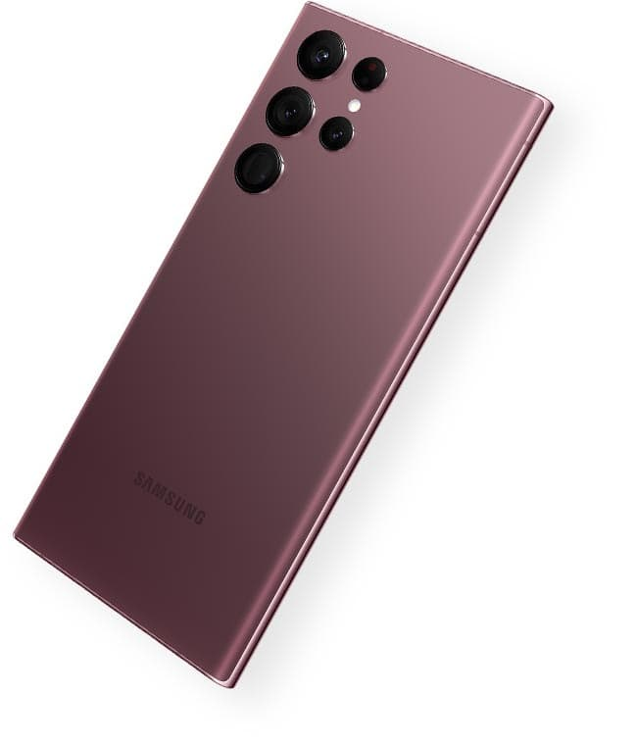

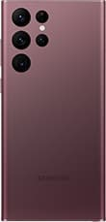

**Galaxy S22 Ultra**

[**LEARN MORE**](https://www.samsung.com/pk/smartphones/galaxy-s22-ultra/)

[**BUY NOW**](https://www.samsung.com/pk/smartphones/galaxy-s22-ultra/buy/)

Amazing alone. Better together

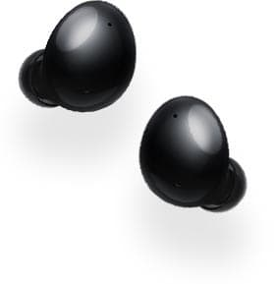

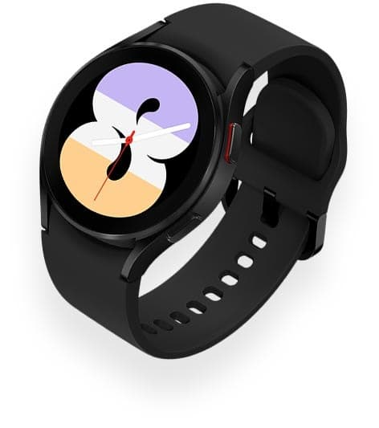

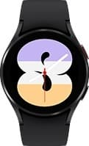

**Galaxy Watch4**

[**LEARN MORE**](https://www.samsung.com/pk/watches/galaxy-watch/galaxy-watch4-black-bluetooth-sm-r870nzkamea/)

[**BUY NOW**](https://www.samsung.com/pk/watches/galaxy-watch/galaxy-watch4-black-bluetooth-sm-r870nzkamea/buy/)

*Galaxy S22 Ultra, Galaxy Tab S8 Ultra, Galaxy Buds2 and Galaxy Watch4 sold separately.

[C](https://www.samsung.com/pk/audio-sound/galaxy-buds/galaxy-buds2-graphite-sm-r177nzkamea/) [C](https://www.samsung.com/pk/audio-sound/galaxy-buds/galaxy-buds2-graphite-sm-r177nzkamea/" \o "Default contrast selected)

1. Auto Switch feature only available on Samsung Galaxy smartphones and tablets with OneUI 3.1 or later and Galaxy Watch 4 series or later. Certain devices and applications may not support Auto Switch.
2. Results are based on Samsung internal lab testing subject to POLQA(Perceptual Objective Listening Quality Analysis), a global standardized test for call quality.
3. ANC(Active Noise Canceling) is on by default, and the touch and hold gesture for ANC can be configured in the Galaxy Wearable app.
4. Changing the 3 levels of ambient sound volume can be set up on Galaxy Wearable app.
5. Available colors may vary by country or carrier.
6. Earbuds and case provide up to 20 hours of battery life when the case and earbuds are charged to 100%. Based on internal testing. Audio playback time tested by pairing a pre-production Galaxy Buds2 to a recently released Galaxy smartphone with default settings including ANC on. Actual battery life may vary and depend on usage conditions, settings, number of times charged, Bluetooth signal strength, and other factors.
7. Play time may vary based on settings.
8. Buds Controller is compatible with Galaxy Buds+, Galaxy Watch4, and their respective following models.
9. Devices sold separately.
10. Auto Switch feature only available on Galaxy smartphones and tablets with OneUI 3.1 or later and Watch which is Galaxy 4 series or later. Certain devices and applications may not support Auto Switch.
11. Samsung Galaxy devices must be logged in to Samsung Account to enable Auto Switch.

**Specifications**

* Compatible Specification of Smartphone**Android 7.0 ↑ , 1.5GB ↑**

* Earbud Weight (g)**5.0 g**

* Bluetooth Version**Bluetooth v5.2**

* Sensors**Accelerometer,Gyro Sensor,Hall Sensor,Proximity Sensor,Touch Sensor,VPU(Voice Pickup Unit)**

[**View more**](javascript:void(0);)

4.2 out of 5 stars, average rating value. Read 17 Reviews. Same page link.

4.2

(17)

Write a review

**Reviews**

Rating Snapshot

Select a row below to filter reviews.

5 starsstars

12

12 reviews with 5 stars.

4 starsstars

2

2 reviews with 4 stars.

3 starsstars

0

0 reviews with 3 stars.

2 starsstars

1

1 review with 2 stars.

1 starstars

2

2 reviews with 1 star.

Overall Rating

4.2

17 Reviews

8 out of 10 (80%) reviewers recommend this product

Review this Product

Select to rate the item with 1 star. This action will open submission form.

Select to rate the item with 2 stars. This action will open submission form.

Select to rate the item with 3 stars. This action will open submission form.

Select to rate the item with 4 stars. This action will open submission form.

Select to rate the item with 5 stars. This action will open submission form.

Adding a review will require a valid email for verification

Filter Reviews

Search topics and reviews search region

Rating

Locale

1 to 8 of 17 Reviews

1 – 8 of 17 Reviews

 Relevancy InfoDisplay a popup with information about Relevancy Sort.

Sort by

Most Relevant

**Anonymous**

Review **1**

Votes **10**

5 out of 5 stars.

**Alway Samsung**

3 years ago

I bought these buds,it’s truly ANC and exclent as it is. Thanks Samsung to make such a amazing products like this.

Yes, I recommend this product.

Helpful?

(10)

(2)

Report

**yasseriftekhar**

Review **1**

Votes **0**

1 out of 5 stars.

**Earbuds pops out of your ear. Disappointed.**

**yasseriftekhar**

2 years ago

I bought this item few days back. I am very disappointed by Samsung this time. These buds are not properly designed. Earbuds pops out of your ear after few minutes of use, you have to adjust your buds time to time and it's very annoying. Also the color shown in the picture was much better than the one i received.

**Cons**Too big, Did not meet expectations

No, I do not recommend this product.



Originally posted on Samsung UAE

**Usama93**

Review **1**

Votes **0**

5 out of 5 stars.

**Great features and sound quality**

a year ago

Great comfort and impressive sound quality i really love them i am using them for one week and i must say they are by far the best sounding handfree that i have tried and it snug in my ear small ears very well even many earbuds dont fit me but they fit like a charm Highly recommend ☺️

Helpful?

(0)

(0)

Report

**KhalilH**

Review **1**

Votes **0**

4 out of 5 stars.

a year ago

Bought the graphite ones back in July. Love their colour. Had to readjust their size to the smallest- now fit perfectly. However, I don't use them during exercise. The sound quality is good and clear as well as the microphone. Dropped them thrice- still working perfectly fine.

Originally posted on [Galaxy Buds2(SM-R177NZTAMEA)](https://www.samsung.com/pk/audio-sound/galaxy-buds/galaxy-buds2-blackonyx-sm-r177nztamea/)

Helpful?

(0)

(0)

Report

**yahyanav**

Review **1**

Votes **0**

4 out of 5 stars.

**Good buds minus average single-charge battery.**

10 months ago

Got them as complementary gift with S23FE while I was using Buds+ before that. Sound is little clear than Buds+. Speaker grill is same as Buds+ so I am yet to see if earwax can block this one as well over time, something that bothered me much with Buds+ after every 2-3 months. In-ear grip is not as good as Buds+ but it's not bad by any means, I am yet to drop them from ear which is a win for me as I don't have to deal with extra pieces of loose bud-grips. I am never worried about them falling out from ear. Passive noise-blocking is better with Buds2. But I am unable to find any noticeable difference with ANC on. At some angles it is able to minimize few noises but that's it. Like any good passive blocking earphones, it blocks sound when music is on, but not when its silent even with ANC on. Single-charge battery is little underwhelming, bud should go through daily workhours with single charge but it's not the case with buds2. But one can go through by charging them a little in break(s). Overall, good basic buds with primitive ANC useful for rare cases.

Helpful?

(0)

(0)

Report

**Ash91**

Review **1**

Votes **0**

5 out of 5 stars.

**Great Product**

a month ago

I've been using these earbuds for over a year, and they’re fantastic. The battery life is excellent, noise cancellation works impressively well, and, most importantly, the sound quality is outstanding.

Yes, I recommend this product.

Originally posted on [Galaxy Buds2(SM-R177NZTAMEA)](https://www.samsung.com/pk/audio-sound/galaxy-buds/galaxy-buds2-blackonyx-sm-r177nztamea/)

Helpful?

(0)

(0)

Report

**alanrd772**

Review **1**

Votes **0**

5 out of 5 stars.

**Great**

**alanrd772**

a year ago

Must buy for those with a Samsung phone! They integrate well with the Samsung ecosystem and have great sound and ANC performance. Transparency mode is also surprisingly natural.

**Pros**Inexpensive, Realistic color, Lightweight, Built-in speakers, Durable

Yes, I recommend this product.



Originally posted on Samsung UAE

**Tknights**

Review **1**

Votes **0**

2 out of 5 stars.

**Can be better**

**Tknights**

a year ago

I've been using these buds 2 for months now and I regret buying it. It falls off my 👂. Even after fitting all d other adjustable buds. Bud live still remain my best

**Pros**Inexpensive, Realistic color, Built-in speakers

**Cons**Did not meet expectations

No, I do not recommend this product.



Originally posted on Samsung UAE

Response from Samsung UAE:

a year ago

**Samsung support**

Your feedback is valuable to us. However, for further support we recommend you to contact us on the channels listed in the link below. https://www.samsung.com/ae/info/contactus/